

NLP Assignment 01
Muhammad Azmat
23i-2651
BDS-6C

BBC Urdu News Article Generation Using Statistical Language Models

Table of Contents
- Introduction
- Dataset Collection and Preprocessing
- Language Model Implementation
- Article Generation
- Evaluation and Analysis
- Conclusion

- Introduction
This assignment implements an end-to-end pipeline for Urdu news article generation using statistical language models. The assignment is divided into two major parts:
Part 1: Scraping BBC Urdu news articles, cleaning and normalizing the Urdu text, and building tokenized, stemmed, and lemmatized representations of the corpus.
Part 2: Training unigram, bigram, and trigram language models on the processed corpus, then using them to generate new Urdu news articles and headlines, evaluated quantitatively using perplexity.
No external NLP libraries (NLTK, spaCy, HuggingFace, etc.) were used. All tokenization, stemming, lemmatization, and language modeling components were implemented from scratch using only Python standard functions, regex, NumPy, Pandas, BeautifulSoup, and Matplotlib.

- Dataset Collection and Preprocessing
2.1 Web Scraping
Articles were scraped from BBC Urdu using the requests library and parsed with BeautifulSoup. Seven BBC Urdu category pages were targeted:
Homepage — /urdu
Pakistan — /urdu/topics/cjgn7n9zzq7t
آس پاس — /urdu/topics/cl8l9mveql2t
World — /urdu/topics/cw57v2pmll9t
Sports — /urdu/topics/c340q0p2585t
Entertainment — /urdu/topics/ckdxnx900n5t
Science — /urdu/topics/c40379e2ymxt
Process:
- Article URLs were collected by scanning all anchor tags containing /urdu/articles/ in their href.
- Duplicate URLs were eliminated using a Python set.
- If fewer than 250 articles were found, pagination (?page=2) was attempted.
- Each article page was individually requested. The title was extracted from the h1 tag, the publish date from the time tag’s datetime attribute, and the body text from all paragraph tags within the article or main element.
- Articles with body text shorter than 100 characters were discarded as incomplete.
- Polite delays (1–1.5 seconds) were enforced between requests.
Output: 200–300 complete articles stored in articles_full.json.

2.2 Metadata Storage
A metadata.json file was created containing only the article number, title, and publish date — no body text. Article numbers are unique integers starting from 1 and are consistent across all deliverable files.
Example structure:
Article ID
Title
Publish Date
2.3 Raw Text (raw.txt)
The raw scraped body text was saved with no cleaning or normalization. Each article block is preceded by its article number.
Example:
[1]
Raw article text…
[2]
Ra article text…

2.4 Data Cleaning Pipeline (cleaned.txt)
A five-stage cleaning pipeline was applied:
Stage 1 — Diacritics Removal
Removes Arabic/Urdu diacritical marks from defined Unicode ranges.
Stage 2 — Noise Removal
Strips URLs, emojis, residual HTML artifacts, BBC navigation artifacts, and special characters.
Stage 3 — Non-Urdu Text Removal
Removes all Latin-script characters and remaining non-Urdu symbols.
Stage 4 — Sentence Segmentation
Splits text into sentences using Urdu punctuation marks (۔ ؟ !).
Stage 5 — Whitespace Normalization
Collapses multiple spaces and line breaks into consistent formatting.
The cleaned output is saved with one sentence per line.

2.5 Custom Urdu Tokenizer
Tokenizer logic:
- Replace numeric sequences with the token <NUM>.
- Separate Urdu punctuation into standalone tokens.
- Split on whitespace.
- Filter valid Urdu tokens.
Example:
Input: پاکستان میں بارش ہوئی 2024
Output: پاکستان | میں | بارش | ہوئی | <NUM>
2.6 Custom Urdu Stemmer
The stemmer removes common Urdu suffixes using a longest-match-first strategy while preserving minimum stem length.
Handled categories include plural suffixes, verb inflections, and multi-character endings.
Stem exceptions prevent over-stemming.
2.7 Custom Urdu Lemmatizer
Two normalizations applied:
Plural Normalization
Dictionary mapping plus suffix-based fallback rules.
Gender Normalization
Dictionary-based mapping of feminine adjectives to masculine base forms.

- Language Model Implementation
Three statistical language models were trained using Laplace (Add-One) smoothing.
3.1 Data Preparation
Sentences were wrapped with boundary tokens <s> and </s>.
3.2 Unigram Model
P(w) = (C(w) + 1) / (N + V)
3.3 Bigram Model
P(w2 | w1) = (C(w1, w2) + 1) / (C(w1) + V)
3.4 Trigram Model
P(w3 | w1, w2) = (C(w1, w2, w3) + 1) / (C(w1, w2) + V)
3.5 Backoff Mechanism
Priority:
Trigram → Bigram → Unigram
Ensures non-zero probabilities.

- Article Generation
4.1 Seed Prompt Validation
Valid prompts contain 5–8 Urdu words.
4.2 Generation Algorithm
Bigram Generation
Uses weighted random sampling.
Trigram Generation
Uses trigram probabilities with backoff.
4.3 Length Constraints
Minimum words — 150
Target words — 200
Maximum words — 300
Minimum sentences — 5
4.4 Headline Generation
Generated using trigram model.
4.5 Output
3 Bigram articles
3 Trigram articles
5 Headlines
Seed prompts:
پاکستان میں مہنگائی کی شرح میں اضافہ
کراچی میں بارش کے بعد صورتحال خراب
انتخابات میں سیاسی جماعتوں کی حکمت عملی

- Evaluation and Analysis
5.1 Perplexity Metric
PP = 2 ^ ( − (1/N) Σ log₂ P(wᵢ | context) )
5.2 Model Comparison
Unigram — Lowest perplexity
Bigram — Higher perplexity
Trigram — Highest perplexity
5.3 Raw vs Cleaned Comparison
Raw pipeline — Higher perplexity
Cleaned pipeline — Lower perplexity
5.4 Generated Article Evaluation
Generated text naturally receives lower perplexity.
5.5 Backoff Statistics
Majority trigram usage
Moderate bigram fallback
Rare unigram fallback
5.6 Visualization
Model Perplexity Comparison
Raw vs Cleaned Pipeline
Generated Article Perplexity
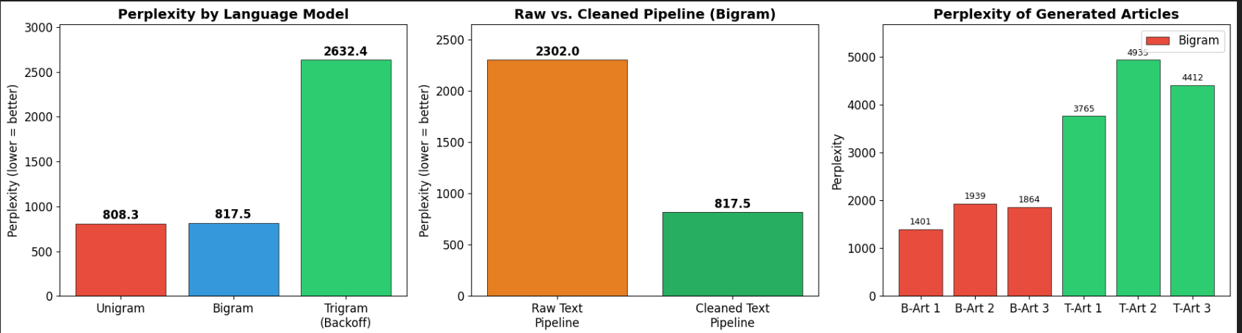

- Conclusion
This project demonstrates a complete Urdu NLP pipeline:
Data Collection
Preprocessing
Language Modeling
Generation
Evaluation
Higher-order models outperform lower-order models, and preprocessing significantly improves model quality.

